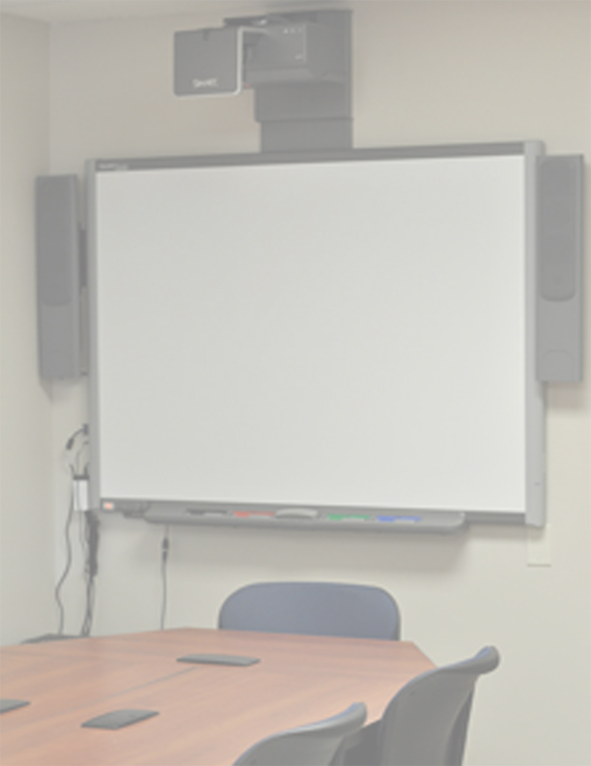THE FOLLOWING WORKSHOPS WILL BE OFFERED BY THE OFFICE OF INFORMATION TECHNOLOGY HELPDESK DURING SPRING 2012.

PLEASE CALL THE HELPDESK AT EXTENSION 3695 TO REGISTER.

Introduction to Windows 7 –
Thursday, March 8th (1:30 – 2:20 or 2:30 – 3:20) This presentation will take place in 2A-306.
Become familiar with the basic functions of the new operating system.

Introduction/Intermediate MS Word 2010 –
Thursday, March 15th (1:30 – 3:30) This hands on workshop will take place in 2N-115.
Learn how to do tables, text styles, tricks, etc..

Meet, Greet & Learn Technology –
Wednesday, March 21st (1:30 – 3:30) This session will take place in 2A-306.
Stop by our office to get your computer/technology questions answered. If you bring your file with
you, we can provide one-on-one support.

Introduction/Intermediate MS Excel 2010 –
Thursday, April 12th (1:30 – 3:30) This hands on workshop will take place in 2N-115.
Become familiar with the basic functions of Excel. Learn how to do formulas & calculations.

Meet, Greet & Learn Technology –
Wednesday, April 18th (1:30 – 3:30) This session will take place in 2A-306.
Stop by our office to get your computer/technology questions answered. If you bring your file with
you, we can provide one-on-one support.

Introduction/Intermediate MS PowerPoint 2010 –
Thursday, May 10th (1:30 – 3:30) This hands on workshop will take place in 2N-115.
Learn how to create PowerPoint presentations.

Meet, Greet & Learn Technology –
Wednesday, May 16th (1:30 – 3:30) This session will take place in 2A-306.
Stop by our office to get your computer/technology questions answered. If you bring your file with
you, we can provide one-on-one support.

Please contact the HelpDesk if you have any questions.

Seating for the presentations is limited to 5 participants per session.
Seating for the workshops is limited to 30 participants per session.
Seating for the Meet, Greet & Learn is by appointment. One-on-one sessions will be schedule in 20 minute intervals.

